Ideation Phase
Define the Problem Statements

Date | 31 January 2025
Team ID | LTVIP2025TMID36086
Project Name | Enchanted Wings: Marvels of Butterfly Species
Maximum Marks | 2 Marks

Customer Problem Statement Template:
Create a problem statement to understand your customer's point of view. The Customer Problem Statement template helps you focus on what matters to create experiences people will love.
A well-articulated customer problem statement allows you and your team to find the ideal solution for the challenges your customers face. Throughout the process, you’ll also be able to empathize with your customers, which helps you better understand how they perceive your product or service.

Reference: https://miro.com/templates/customer-problem-statement/

🧠 Customer Problem Statement Template
Create a problem statement to understand your customer's point of view. The Customer Problem Statement template helps you focus on what matters to create experiences people will love.
A well-articulated customer problem statement allows you and your team to find the ideal solution for the challenges your customers face. Throughout the process, you’ll also be able to empathize with your customers, which helps you better understand how they perceive your product or service.
🔗 Reference: MIRO Template

Example:
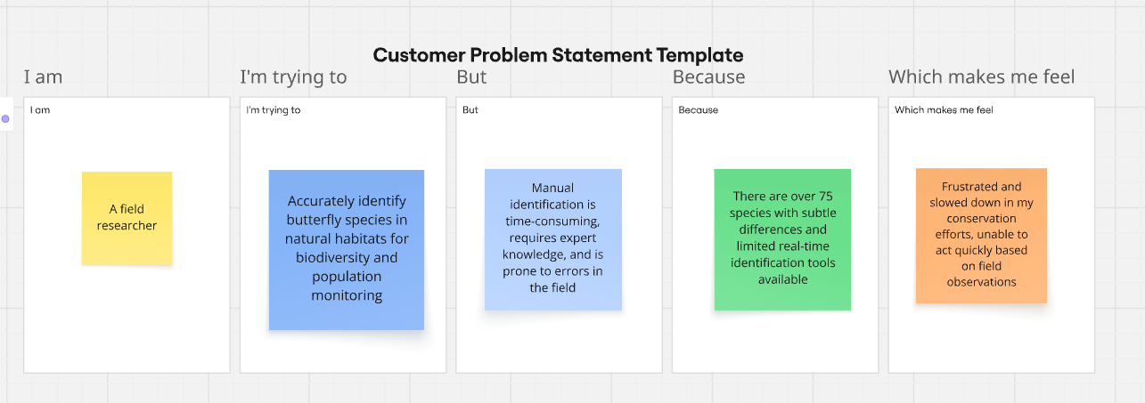
Problem Statement (PS) | I am (Customer) | I’m trying to | But | Because | Which makes me feel
PS-1 | A field researcher or conservationist | Accurately identify butterfly species in natural habitats for biodiversity and population monitoring | Manual identification is time-consuming, requires expert knowledge, and is prone to errors in the field | There are over 75 species with subtle differences and limited real-time identification tools available | Frustrated and slowed down in my conservation efforts, unable to act quickly based on field observations
PS-2 | A student, educator, or nature enthusiast participating in citizen science projects | Learn more about butterfly species and contribute to environmental conservation efforts | I don’t have access to expert identification tools or apps to recognize species accurately | Most resources are either too complex, outdated, or not built for public engagement | Discouraged from participating in nature-based projects and disconnected from biodiversity efforts

